2008 National English Contest for College Students
(Level D-Preliminary)
Part I Listening Comprehension (25 minutes，30 marks)
Section A：In this part，you will hear seven recordings．The seven recordings will be played only once. At the end of each recording, a question will be asked about what was said．After each question, there will be a pause．During the pause，look carefully at the three pictures marked A，B and C, and decide which picture answers the question. Then mark the corresponding letter on the Answer Sheet with a single line through the centre. (7marks)
1．What time does the film start?
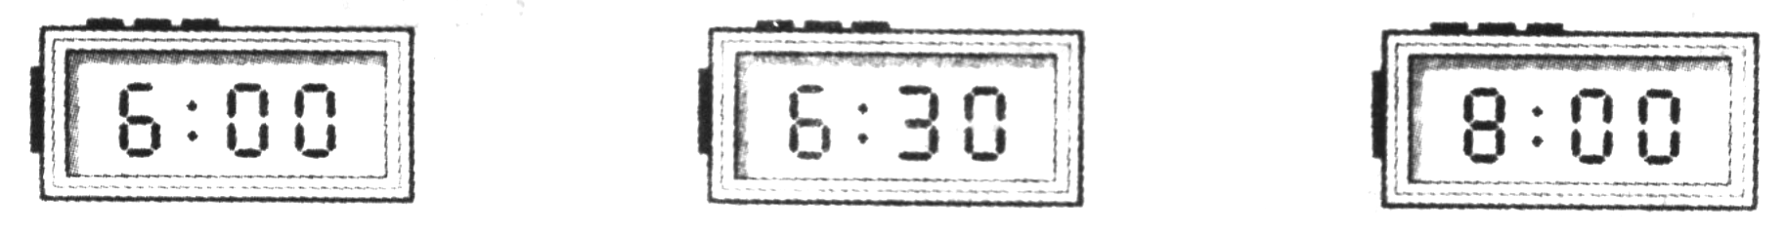

A． B． C．
2．What season is the speaker describing in the poem?
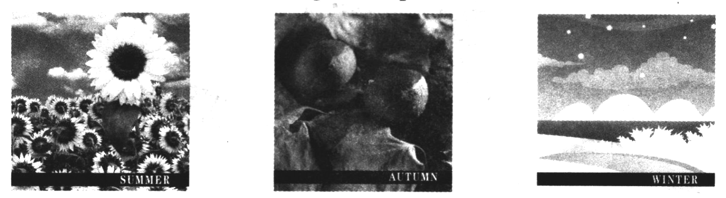

A． B． C．
3．Which graph is the speaker talking about?
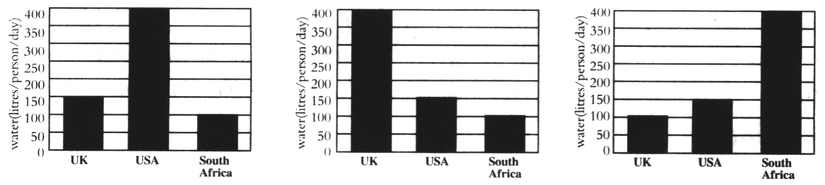

A． B． C．
4．How does Jack come into the office?
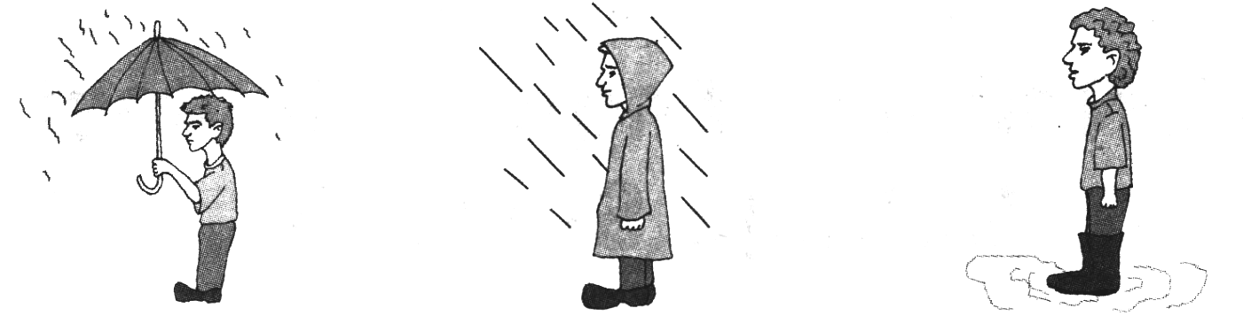

A． B． C．
5．Why does the speaker want some coins?
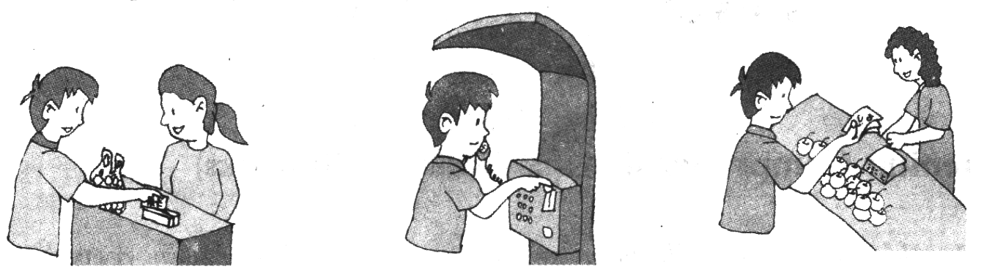

A． B． C．
6．Which subjects does Mike think is the most difficult?
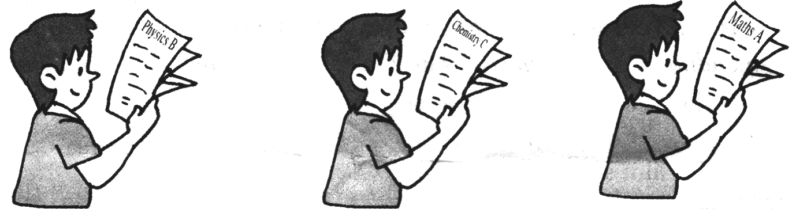

A． B． C．
7．What does Henry drink after breakfast now?
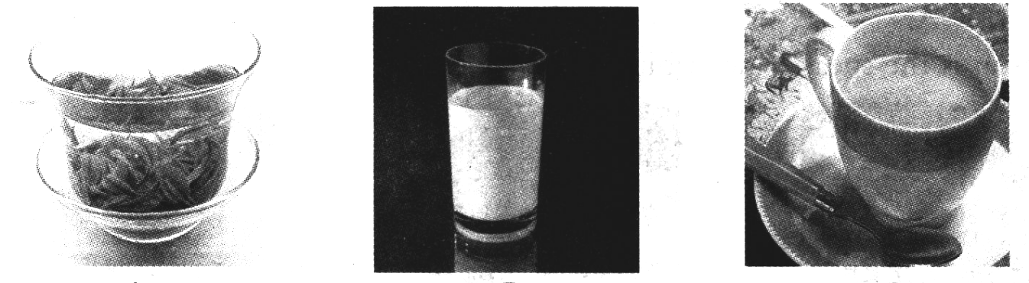

A． B． C．
Section B：In this section, you will hear 8 short conversations．At the end of each conversation, a question will be asked about what was said．Both the conversation and the question will be read only once. After each question，there will be a pause．During the pause，read the three choices marked A，B and C，and decide which is the best answer．Then mark the corresponding letter on the Answer Sheet with a single line through the centre．(8 marks)
8．A．The coffee table． B．The couch． C．The desk．
9．A．This Friday． B．This weekend． C．Monday through Friday．
10．A．In Hong Kong． B．In the mail． C．With Susan．
11．A．By train． B．By bus． C．By plane．
12．A．He has poor eyesight．
B．The newspapers have been sold out．
C．There are no English magazines．
13．A．Get to the train station． B．Get out of the heat． C．Take a walk．
14．A．Baked goods． B．A building． C．A restaurant．
15．A．Lend Paul her computer． B．Sell him an adapter． C．Ask a friend for help．
Section C：In this section, you will hear one long conversation．The conversation will be played only once．At the end of the conversation，there will be a one-minute pause. During the pause, read the five questions，each with three choices marked A，B and C，and decide which is the best answer．Then mark the corresponding letter on the Answer Sheet with a single line through the centre．(5 marks)
Questions 16 to 20 are based on the conversation you have just heard．
16．Where does this conversation probably take place?
A．At Jane’s． B．At an office． C．At a bar．
17．How much does the most expensive wine cost?
A．Almost $1,600． B．Nearly $6,000． C．Around $60,000．
18．What does lane say about the most expensive wine?
A．It is the oldest wine． B．It is over 200 years old．
C．It was produced in Washington，D．C．
19．What does the man think about the wine?
A．It’s very special． B．It’s too expensive． C．It’s better than buying a house．
20．What is it said that Thomas Jefferson did with the wine?
A．He introduced it to George Washington．
B．He kept several bottles of it in Washington．
C．He passed the wine down to his descendants．
Section D：In this section, there is a short passage．Listen to the passage carefully, and then fill in the blanks with the words or phrases you hear on the tape．Remember to write the answers on the Answer Sheet．(10 marks)
Good morning and welcome．I'm here today to talk about time management．My aim is to (21)___________ some techniques which will help you to use your time more efficiently．
Time is (22)____________ money，people and equipment．It’s a limited (23)____________. Time management is about making the best (24)_____________ use of it．So，what are the (25)___________ of time management? Today we’re going to look at three fundamental steps.
The first step is to (26)____________ how you use your time now．This requires a methodical approach．Break your day into half hour periods．Record what you do in each period．
The next step is to prioritise. Take the tasks which genuinely (27)___________ and put them in order of priority — which are the most important，which are (28)____________.
(29)____________, organize your time and your tasks．Ask yourself“How much time will I need?” Be realistic because work tends to expand to fill the time (30)____________.
PartⅡVocabulary and Structures (10 minutes．15 marks)
There are 15 incomplete sentences in this part．For each blank，there are four choices marked A，B, C and D. Choose the one that best completes the sentence．Then mark the corresponding letter on the Answer Sheet with a single line through the centre．
31．We had an exciting __________on the Trans-Siberian railway last week．
A．travel B．trip C．tour D．cruise
32．I have an urgent problem and I need to call my parents，but I’m afraid I haven’t got ____________change — only a ￡10 note．Will you do me a ____________?
A．any；favour B．a lot；help C．some；hand D．a few；support
33．We still couldn’t hear Professor Wang clearly at the business lecture, so we all asked him to speak _____________.
A．slow B．more slow C．slower D．more slowly
34．The pilot succeeded in ___________ the helicopter ___________ the cliff．
A．stopping；at B．mending；in C．flying；on D．landing；on
35．___________my husband and I ____________ down the road yesterday evening, we heard a woman scream．
A．Since；had walked B．While；have walked
C．As；were walking D．When；are walking
36．He won’t be expecting a present，so you ___________ buy him one．
A．can’t B．have to C．don’t need D．needn’t
37．Pierre left without saying a word to the boss because he cannot stand __________ to wait．
A．be made B．to be made C．being made D．be making
38．Fiona said that she felt quite embarrassed that day because she was not accustomed to _____________ like that．
A．be treating B．have been treated C．being treated D．be treated
39．I saw a comic film，____________ was very amusing，last Saturday. In fact，it was the best film ____________ I’ve ever seen．
A．which；what B．that；which C．which；that D．that；what
40．It seems that you’ve caught a bad cold．You’d better see a doctor，___________ you?
A．hadn’t B．didn’t C．wouldn’t D．don’t
41．Mr．Smith managed to eat lunch ____________ having had an enormous breakfast.
A．despite B．since C．because D．although
42．If it rains on Saturday, we shall have to ____________ the match for a week．
A．bring on B．put away C．take off D．put off
43．He is not satisfied with his exam results and wishes he ___________ harder for his exams．
A．has studied B．would study C．studies D．had studied
44．—Do you want to eat out tonight or shall we cook something?
一____________I can’t afford to eat out again．
A．I really need a coffee． B．Let’s cook．
C．Let’s do that，then． D．That would be nice．
45．一He locked himself out of his car yesterday．
一Oh，he’s always doing things like that! ___________
A．He’s a lovely person． B．He’s very careless．
C．He’s always happy． D．He’s quite generous
Part III Reading Comprehension (20 minutes，40 marks)
Section A：There is one passage in this section with 5 questions．For each of them, there are 4 choices marked A，B，C and D．You should decide on the best choice．Then mark the corresponding letter on the Answer Sheet with a single line through the centre．(5 marks)
Questions 46 to 50 are based on the following passage．
The main topic of last week’s meeting was suggestion boxes．All departments in the factory are to have labeled suggestion boxes．At the meeting，it was obvious that the employees’ suggestions would not only save the company money，but would do much to lift spirit and streamline production．To further this process，the suggestion box idea was adopted．
Forms for the suggestions are to be kept inside the box．When employees fill out a form，they should clearly state which situation they are trying to improve，list all data，and then offer a solution，stating how the company would benefit．Forms will then be collected each month by the department heads，who will then pass them on to the plant manager．Where necessary，the plant manager will consult with the respective departments to gather any relevant data．If applicable，the matter will then be passed on to the finance department for approval．A bonus will be paid to employees for any suggestions that are adopted．The amount of the bonus will be in proportion with the savings to the company．
Questions：
46．What is the topic of the report?
A．A meeting． B．Spirit． C．Production．D．A new system。
47．Why has the company decided to use suggestion boxes?
A．To take advantage of the employees’ ideas．
B．To minimize customer complaints．
C．To take some of the burden off department heads．
D．To calm the finance department．
48．How do the employees get the suggestion slips?
A．By requesting them from department heads．
B．By applying to the plant manager．
C．By looking in the suggestion box itself．
D．By asking the director of finance．
49．What is the plant manager supposed to do?
A．Review each suggestion with the employee．
B．Issue bonus checks．
C．Pass the suggestions to the finance department．
D．Collect relevant data if necessary．
50．What should employees specifically include in their suggestions?
A．The names of troublesome coworkers．
B．How long the problem has existed．
C．What they consider is an appropriate bonus．
D．A description of what they would like to change．
Section B：In this section, there is one passage followed by 5 statements．Go over the passage quickly and mark the answers on the Answer Sheet．For Answers 51—55．Mark T (for TRUE) if the statement agrees with the information given in the passage；F (for FALSE) if the statement contradicts the information given in the passage．(5 marks)
Questions 51 to 55 are based on the following passage.
Dear Advisor：Should She Propose?
Dear Advisor，
My boyfriend and I just celebrated three years together．I want to ask him to marry me．My friends say I shouldn’t．They say that only desperate women propose marriage．Are they right?
Nervous in New Jersey
Dear Nervous，
Your friends are not right．Today it is fine for a woman to propose to a man．In 2003，the Korbel Champagne Company conducted a survey．They asked，“Should women ask men to marry them?”Sixty-seven percent of Americans said yes．The survey asked women．“Would you propose to a man?”Almost 50 percent of the women said they would．They also asked men，“Would you accept a woman’s proposal?” Almost 80 percent said yes．Thirty-one percent of women know a woman who has proposed to a man．
Experts generally agree．Dr．Linda O’Connor has a radio talk show about love and marriage．O’Connor says that women who propose are usually educated and self-confident．In addition，their boyfriends usually like strong women．However，advice columnist Susan Fine argues that even women with a lot of self-confidence may need some help with their proposals．Here is her advice．First，the proposal should not be a surprise．The relationship should be serious．She also advises women to do two more things．They should write out the proposal and practice it before they ask for their boyfriends’ hands in marriage．
How would Susan Fine answer you? If you and your boyfriend are happy，do not pay attention to your friends．And don’t invite them to the wedding．
The Advisor
Statements：
51．“Nervous in New Jersey”wrote to Susan Fine．
52．“Nervous in New Jersey”wants to get married．
53．In 2003 most women said that only men should propose to women
54．Dr．Linda O’Connor is a lawyer．
55．The advisor told“Nervous in New Jersey”to propose to her boyfriend
Section C：Read the passage carefully and answer Questions 56 to 63. Answer each question in a maximum of 10 words．Remember to write the answers on the Answer Sheet．(16 marks)
Preserving the Past
Today，many old buildings are being torn down so new ones can be built．But some older buildings are both beautiful and interesting．They need to be saved．
The city of San Antonio，Texas，was settled by the Spanish in the early 1700s．Later, it was governed by Mexico．If you go to San Antonio，you can see many missions or churches that were built by the Spanish．All were started between 1720 and 1731．You can also find other buildings from early periods in the history of Texas．Some of these buildings are still standing because a group of women worked to save them．
In 1924，the city of San Antonio was going to cement over the San Antonio River and turn it into an underground sewer．A group of women felt that the beauty of San Antonio should be preserved．They formed a club to keep the river from being destroyed．
The women saved the river．Then they worked together to preserve several old buildings that were going to be torn down．In the 1930s，the women saved an old mill and granary．They raised money to buy these buildings by giving tea parties and selling cakes．
More recently，the ladies in San Antonio have worked to save a Spanish convent．They could not afford to buy the whole building，so they paid for only half. Even so，the women are still looking for other old buildings to save．They want people to know about the city’s long and interesting history．
Questions：
56．What is the passage mainly about?
57．What does the word ones in Sentence 1 refer to?
58．When was San Antonio in Texas settled?
59．What can you see if you go to San Antonio?
60．The word in Paragraph 3 that means saved is ____________.
61．How did the women raise money to buy old buildings?
62．Why did the women want to save the San Antonio River?
63．Why have the women worked to save the river and old buildings?
Section D：In this section, there is one passage followed by a summary．For Answers 64 to 70，please read the passage carefully and complete each space in the summary, using a maximum of three words from the passage．Remember to write the answers on the Answer Sheet．(14 marks)
Answers 64 to 70 are based on the following passage．
Around the world，music therapy is being used to treat different medical conditions and illnesses．Some of the ways people use music therapy are to reduce pain，such as childbirth or during cancer treatments，or to stimulate brain activity after an injury or memory loss．Music therapy has also been successful in aiding children to overcome disabilities．
Classical music is most typically used for therapies due to its complex sounds and patterns．Although rap or pop might be fun to listen to，it’s unlikely that such styles of music would produce the same kind of therapeutic effect．Playing a musical instrument rather than simply listening to music can also be therapeutic for some people，helping relieve stress and anxiety.
Have scientists been able to prove that music can heal diseases? Music has been shown to reduce pain in cancer patients by increasing the release of endorphins．Endorphins are the body’s natural painkillers，and when we listen to music，our brains respond by releasing these natural painkillers．It has also been known to contribute to the brain development of new born babies and even babies still in the mother’s womb. Currently, music therapy is used in a variety of settings such as hospitals, rehabilitation centers, nursing homes, day care centers, and schools.
Summary：
There appears to be some evidence that music is helpful (64)______ some medical conditions. Therefore, doctors and patients are turning to (65)_________ to treat various (66) _________ and disabilities．Doctors believe that music with (67)__________ and patterns is more effective．This kind of music seems to (68)________ more activity in the brain．Although it may be (69)_______
to listen to rap or pop or dance music，doctors prefer to use (70)___________ to treat patients.
Part IV Cloze (15 minutes，15 marks)
Section A：Read the following passage carefully, and then fill in the blanks with the proper form of the words given on the right. Remember to write the answers on the Answer Sheet. (5marks)

It is a fairly common (71)_________ in Britain that men these days do more housework than they did in previous generations. But is this really so? A recent survey has made some interesting discoveries.  (72)__________, when men do help out, they enjoy cooking and shopping but most are (73)__________ to doing the washing. A quarter of men think that women are better suited to looking after the home than men and 19% admit to (74)__________ no contribution to housework. The average man says that he does a (75)__________ of the housework, while the average woman says she does three-quarters of it, so someone isn’t telling the truth! It was impossible to find any men who shared housework equally with their partners. Perhaps it is not so surprising, therefore, that there are some politicians who want a new law forcing men to do their share. | believe  apparent  willing  make  three
Section B: There are 10 blanks in the passage. For each blank, some litters of the missing word have been given (not exceeding 3 letters). Read the passage below and decide which word best fits each blank. Use only one word in each blank. Remember to write the answer on the Answer Sheet．(10 marks)
The Museum of Childhood
There are 4,000 toys in London’s Museum of Childhood，but it is not essential to be a child to enjoy it．Most of the older toys were (76)me__________ to be played with by adults．
All the toys live in a beautiful glass-topped (77)bu___________ in the East End of London—but it wasn’t built for them．It was opened in 1872 and displayed art, shoemaking and furniture (78)col___________. It wasn’t until 1974 that the (79)wh____________ building was officially devoted to the history of childhood．
Once upon a time，every toy was home-made，although by the late 1700s a huge toy industry had (80)dev____________. Many home-made toys were made of metal and wood and a few of these have lasted well enough for the museum to display them．It even has one of the oldest dolls’ houses still in (81)exi___________, made in 1673．There’s something for everyone，including the 18th century toy theatre and the miniature Chinese gardens，containing tiny (82)ani___________. Whichever is your favourite，each exhibit enables you to catch a (83)gli__________ of the people and world it was made for．
The 35 or so workers at the museum take great care to make sure that all of the exhibits are preserved in good working order．And as (84)f___________ the 500 new toys that move in every year from all over the world — nobody has ever heard a (85)sin____________ one complaining．
Part V Translation (15 minutes，15 marks)
Section A：Translate the underlined sentences in the following passage into Chinese．Remember to write the answers on the Answer Sheet．(8 marks)
Recently，I saw a heading for an Internet article that read，“If only I’d bought that stock…”Well，sure，hindsight is wonderful! We all have it．But the line made me think：(86) How much time do we spend thinking of the many“If onlys”in our lives? How many regrets flit through our thoughts? Everyone harbors a few — if only I hadn’t missed this；if only I’d found the time to do that；(87) if only I’d been first with that idea, instead of just a little too late．
“If onlys”are exercises in futility．I think it’s better to fill our reveries with all we are glad we did do．Such as，I’m so glad I met my husband．I’m so glad I was born in this time，in this place，to these parents．(88) I’m so glad I have the loving extended family who have been among my greatest blessings．
I’m so glad I planted that spindly little magnolia tree 20 years ago．(89) Now it lifts up its arms to the sky and fills my view with pink-and-white beauty．I’m so glad my grandfather planted apple trees 100 years ago．They，too，are a wonder to behold in any season — alive with honeybees among the blossoms in spring，studded with burgeoning fruit in summer，and weighed low with their delicious rosy bounty in September．
Section B：Translate the following sentences into English, using the words given in the brackets．Remember to write the answers on the Answer Sheet．(7 marks)
90．谢谢您的邀请，但是恐怕我无法应邀出席。(invite)
91．任何人，不管是二十岁还是八十岁，停止学习就会衰老。(whether…or…)
92．有时候我们可能会阅读杂志中的某篇文章或书籍中的某一篇章，它们可能会激发我们去思考，并将自己的观点与作者的观点进行比较。(stimulate；compare…with…)
Part VI IQ Test (5 minutes，5 marks)
There are 5 IQ Test questions in this part．Write the answers on the Answer Sheet．(5 marks)
93．The numbers in the middle section have some connection with those down the sides．What should be there to replace the question mark?
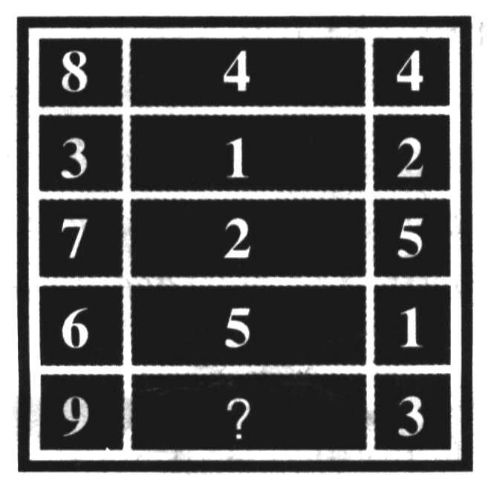

94．I bought four things this morning．The dictionary was 5 times the cost of the book，the tie was 30 times the cost of the book，the watch was 4 times the cost of the tie，and I spent 312 dollars in total．What was the price of the dictionary?
95．A farmer has a field containing a certain number of pigs and hens．Between them they have 36 heads and 100 feet．How many pigs and hens does the farmer have?
96．There is a word of 7 letters．The first 3 letters is for female，the first 4 is for a brave man, and the whole is for a brave woman．What word is this?
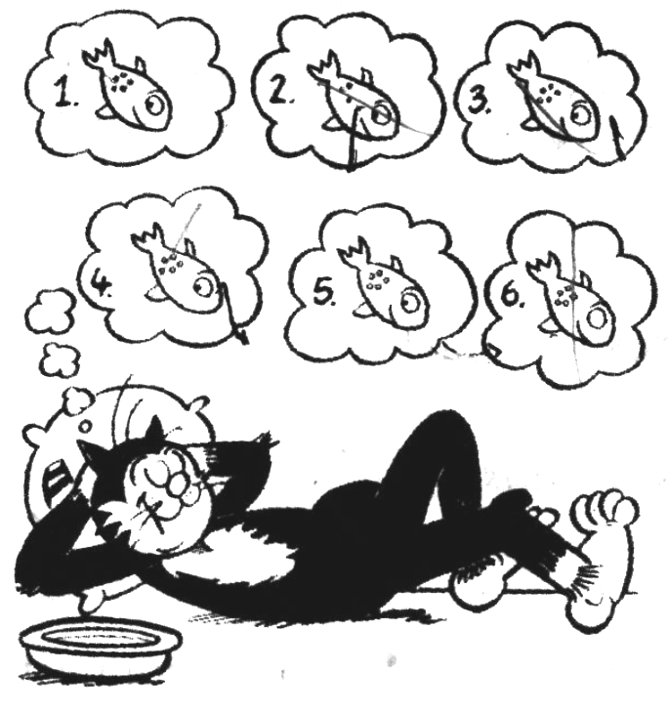
97．Korky is dreaming about his favourite food — fish! But only two of the fish are the same — can you spot them?

Part VII Writing (30 minutes，30 marks)
Task I: You are required to write an email of no fewer than 80 words to your manager, according to the following information given in Chinese．You should include all the points listed in the following table．Now write the message on the Answer Sheet．(10 marks)
收件人电子邮件地址 | gwenliu@hotmail.com
主 题 | 生产情况
内 容 | 1．生产活动完全正常，日产量50万吨。  2．生产上急需的煤已经于今天上午送到。  3．HAD公司来函，要求续签一年的合同，现在手续已办妥。
发件人 | 生产部 李程远
TaskⅡ：Your class has recently had a discussion about learning a foreign language, For homework, your teacher has asked you to write a composition of no fewer than 120 words，giving your opinion about the following statement：
The best way to learn a foreign language is to study it in the country where it is spoken．
Please write your composition on the Answer Sheet. (20 marks)
2008 National English Contest for College Students
(Level D - Preliminary)
参考答案及作文评分标准
Part I Listening Comprehension (25 minutes, 30 marks)
Section A (7 marks)
1-7 BBAABAC
Section B (8 marks)
8-15 BBCCAABC
Section C (5 marks)
16-20 CCBBA
Section D (10 marks)
21. share 22. like 23. resource 24. possible 25. basic concepts 26. analyse
27. require your attention 28. urgent needs 29. Lastly 30. available
Part II Vocabulary and Structures (10 minutes, 15 marks)
31-35 BADDC 36-40 DCCCA 41-45 ADDBB
Part III Reading Comprehension (20 minutes, 40 marks)
Section A (5 marks)
46-50 DACDD
Section B (5 marks)
51-55 FTFFT
Section C (16 marks)
56. Saving interesting old buildings. / Conservation of old towns / cities / San Antonio.
57. Buildings.
58. In the early 1700s.
59. Many missions or churches built by the Spanish.
60. Preserved.
61. By giving tea parties and selling cakes.
62. They wanted to preserve the beauty of San Antonio.
63. They want people to know about San Antonio's history.
Section D (14 marks)
64. for treating 65. music therapy / music 66. illnesses 67. complex sounds 68 stimulate 69. fun 70. classical music
Part IV Cloze (15 minutes, 15 marks)
Section A: 71. belief 72. Apparently 73. unwilling 74. making 75. third
Section B: 76. meant 77. building 78. collections 79. whole 80. developed 81. existence 82. animals 83. glimpse 84. for 85. single
Part V Translation (15 minutes, 15 marks)
Section A (8 marks)
86. 我们花了多少时间来思考我们生活中的许多 "要是……该多好啊"？
87. 要是我没有稍微晚了一步而是第一个想到那个主意该有多好。
88. 我多么高兴拥有这样一个充满关爱的大家庭， 他们始终是我最大的福分。
89. 现在它将自己的枝干伸向天空， 映入我眼帘的是那粉红色和白色相间的美丽景象。
Section B (7 marks)
90. Thank you for your invitation, but I'm afraid I can't come. / It's very kind of you to invite me but I'm afraid I can't come.
91. Anyone who stops learning is old, whether at twenty or eighty.
92. Sometimes we may read an article in a journal or a passage in a book which may stimulate us to think and then compare our opinions with the writer's views.
Part VI IQ Test (5 minutes, 5 marks)
93. 6.
94. 10 dollars.
95. 14 pigs and 22 hens.
96. Heroine.
97. 1 and 5.
Part VII Writing (30 minutes, 30 marks)
Task I (10 marks)
参考范文略
Task II (20 marks)
参考范文略
Task I (10 marks) 应用文评分标准|
一、评分原则：
1. 本题满分为10 分。
2. 评分时，先根据文章的内容和语言初步确定其所属档次，然后以该档次的要求来衡量、确定或调整本档次，最后给分。
3. 词数少于80的，从总分中减去2分。
4. 如书写较差，以致影响阅卷，将分数降低一个档次。
二、各档次的给分范围和要求：
第四档：9-10分
完全符合写作格式的要求，覆盖所有内容要点，表达思想清楚，文字通顺，连贯性很好，基本上无词汇和语法错误。
第三档：6-8 分
基本符合写作格式的要求，有个别地方表达思想不够清楚，文字基本通顺、连贯，有少量词汇和语法错误。
第二档：3-5 分
未恰当完成写作格式的要求，漏掉内容要点，表达思想不清楚，文字多处出现词汇和语法错误，影响了对写作内容的理解。
第一档：1-2 分
未完成写作格式的要求，明显遗漏主要内容，表达思想紊乱，有较多词汇和语法的重大错误，未能将信息传达给读者。
0 分
白卷；作文与题目毫不相关；内容太少，无法评判；所写内容无法看清。
Task II (20 marks) 议论文评分标准
一、评分原则：
1. 本题满分为20 分。
2. 评分时，先根据文章的内容和语言初步确定其所属档次，然后以该档次的要求来衡量、确定或调整本档次，最后给分。
3 .词数少于120的，从总分中减去2分。
4. 如书写较差，以致影响交流，将分数降低一个档次。
二、各档次的给分范围和要求：
第四档：16-20分
完全符合写作格式的要求，覆盖所有内容要点，表达思想清楚，文字通顺，连贯性很好，基本上无词汇和语法错误。
第三档：11-15分
基本符合写作格式的要求，有个别地方表达思想不够清楚，文字基本通顺、连贯，有少量词汇和语法错误。
第二档：6-10分
未恰当完成写作格式的要求，漏掉内容要点，表达思想不清楚，文字多处出现词汇和语法错误，影响了对写作内容的理解。
第一档：1-5 分
未完成写作格式的要求，明显遗漏主要内容，表达思想紊乱，有较多词汇和语法的重大错误，未能将信息传达给读者。
0 分
白卷；作文与题目毫不相关；内容太少，无法评判；所写内容无法看清。

